|  |
| --- |
| **Saurabh Kakodkar**  **Address:** House no. 1174, Near Ram Mandir, Pontemol, Curchorem, Goa - 403706  🕽 07875265818 (M)  **Email:** kakodkarsaurabh@gmail.com |

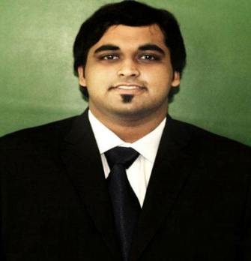

**Curriculum Vitae**

|  |  |  |  |  |
| --- | --- | --- | --- | --- |
| Objective | | To gain a position that utilizes all my skills, helps me sharpen my competencies and enables me to make a positive contribution to the organization.  To attain success by working and doing things in such a way that would give me satisfaction. | | |
| Profile | | Completed Masters in Business Administration majoring in the field of marketing. Completed a course in Japanese culture and corporate management. Trustworthy and responsible with an urge to learn new things. Excellent communicative and interactive skills with experience in public speaking. | | |
|  |  | |  |

Achievements

* Studied Japanese culture and corporate management at Nihon University of International Relations, Mishima, Japan.
* Represented my college and university in all Goa university cricket, badminton tournaments.
* Worked for NGO’s such as Goa Going Green
* Won numerous essay writing competitions at school level.
* Volunteered for Lusofonia Games 2014 as a sports assistant.

Internship Details

|  |  |
| --- | --- |
| **Company Profile** | **Go Search** is a web based local search engine and advertising platform for Goan businesses. Go search is an information service provider which enables the users to search their needs in an effective way.  The company was founded in 2011 in Vasco da Gama as a sms and web based search service.  This company helps local businesses to advertise and effectively market their businesses and products according to their needs.  Go Search ensures a better platform to every small and big enterprise to mark their existence in the competitive world of business hence giving the business a greater dimension and a better reach to their potential customers within the state. |
| **Internship Duration** | 2 April 2013 – 28 May 2013 |
| **Work Responsibilities** | * Acquiring new clients and increasing brand awareness of **Go Search** through social media marketing by sharing of content, videos, and images for marketing purposes. * Potential customers selection based on a geographical selection criteria for example (cities where businesses are extensive) * Educating the end users and potential clients about how to use this service to their benefit and increase the traffic on their website. * Providing advertisements in newspapers and strategic information placing in public areas which ensured online viewership. |

|  |  |
| --- | --- |
| Additional Skills | Adobe Photoshop 6 and Microsoft Office (Microsoft Word, PowerPoint & Excel). |

|  |  |  |  |  |
| --- | --- | --- | --- | --- |
| **Degree** | **Institution** | **University/**  **Board** | **Year of Passing** | **Grade** |
| **MBA**  **(Major in Marketing)** | Goa University | Goa University | 2012-2014 | B |
| **BSC (Computer Science)** | Government College of Arts, Science and Commerce, Quepem, Goa | Goa University | 2012 | First Class |
| **HSSC** | Shree Damodar Higher Secondary School of Science, Margao, Goa | Goa University | 2009 | First Class |
| **SSC** | New Educational Institute, Curchorem, Goa | Goa University. | 2007 | Distinction |

Education

Personal details and Interests

Name: Saurabh Kakodkar

Date of Birth: 11 December 1991

Nationality: Indian

Gender: Male

Marital Status: Single

Languages Known: English, Hindi, Konkani, Marathi and basic Japanese

Interests: Sports, playing guitar, bass and singing, reading novels and magazines, cycling, working for NGO’s.

**Declaration:** I hereby declare that the above information is true to my knowledge.